Riphah International University
Gulberg Green Campus Islamabad
Faculty of Computing (WISH)



Name: Anisha Rehmat.
Sap ID: 78019.
Submitted To: Mam Nayab Khalid
Submitted by: Anisha Rehmat.

Supervision and Coordination

Miss Hira Jafar
Lecturer
Faculty of Computing

Lab Designers

Miss Nayab Khalid
Teaching Fellow
Faculty of Computing

Lab Task 5

Learning Outcomes:

• Apply unary operators to modify object state inside class methods.
• Use the ternary operator as a compact alternative to simple if-else logic.
• Build multi-branch decisions with an if / else-if / else ladder.
• Select among fixed categories cleanly using a switch statement.
• Override toString() so printing an object produces a meaningful summary.

Lab Tasks:-

Lab Task 1- Movie Ticket Counter
Create a class CinemaHall that tracks how many seats have been booked out of a fixed capacity, using increment/decrement to book and cancel seats.
Requirements:
1. Create a class CinemaHall with a private int bookedSeats (start at 0) and a final int capacity (e.g. 100).
2. Write a method bookSeat() that increments bookedSeats using the ++ operator, but only if seats remain.
3. Write a method cancelBooking() that decrements bookedSeats using the -- operator, but never below 0.
4. Write a method showStatus() that prints the number of booked seats and the number of seats remaining.
5. In main(), book 5 seats, cancel 2, then display the status.

Input:-
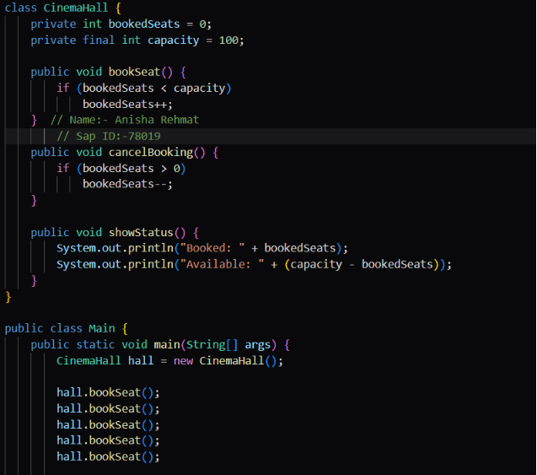
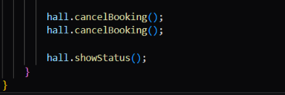
Output:-
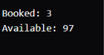

Lab Task 2- Utility Bill Category
Create a class UtilityBill that classifies a household's electricity usage into a billing slab using an else-if ladder.
Requirements:
1. Create a class UtilityBill with attributes consumerName (String) and unitsConsumed (int).
2. Write a method classifySlab() with an if / else-if / else ladder that prints: "Lifeline" for units below 100, "Slab-1" for 100–200, "Slab-2" for 201–300, "Slab-3" for 301–700, and "Slab-4" above 700.
3. Compute and print an approximate bill amount based on a fixed rate per unit for each slab (choose your own reasonable rates).
4. Create at least four UtilityBill objects covering different slabs and display each one's classification and bill.

Input:-

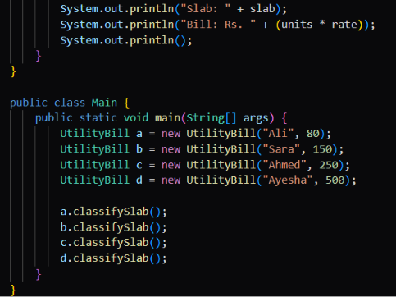

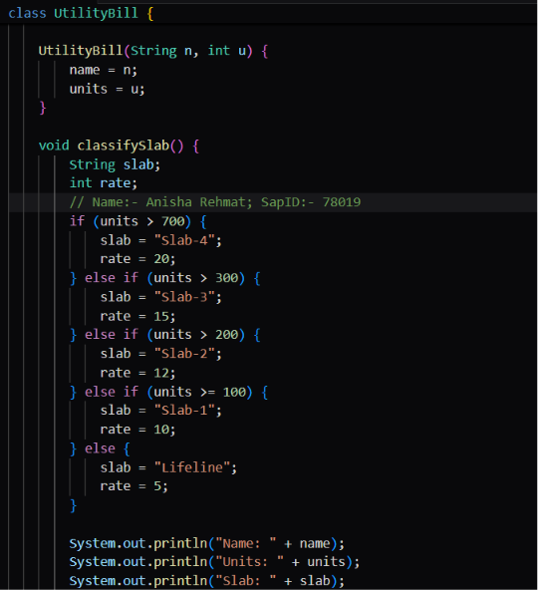

Output:-
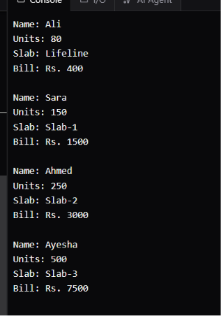

Lab Task 3 - Bank Account Summary
Create a class BankAccount whose objects print a clean, formatted summary automatically when passed to println().
Requirements:
1. Create a class BankAccount with private attributes accountHolder (String), accountNumber (String) and balance (double).
2. Implement a constructor that initializes all three attributes.
3. Override toString() to return a formatted string such as: "Account[1234-5678] — John Doe — Balance: $15000.00".
4. In main(), create two BankAccount objects with sample data.
5. Print both objects directly with System.out.println() and confirm your overridden toString() runs automatically.

Input:-
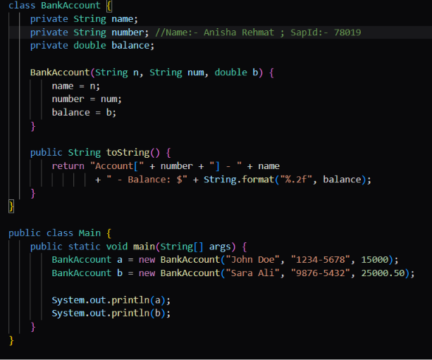
Output:-
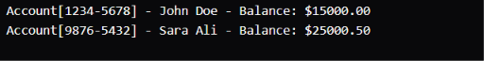

_____________ The End _____________

